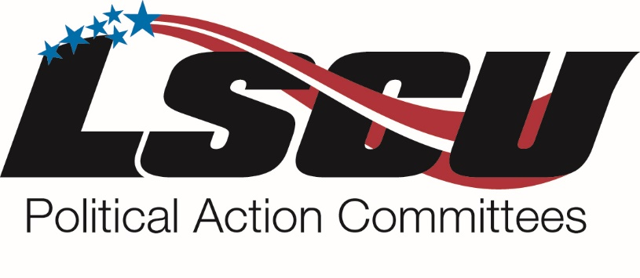
LSCU is a non-partisan organization whose mission is to ensure an operating environment through advocacy, leadership, and services that will enable credit unions to maximize their potential as unique financial institutions.

A Call to Action

Advocacy and grassroots efforts for the credit union movement in Montgomery and Washington help elected officials hear our voice, but unfortunately, that is only half the battle. In the political world, financial contributions are the best way to hold lawmakers accountable. Your contribution to the LSCU PACs allows our industry to remain politically relevant. Below are reasons to consider contributing to the LSCU PACs:

- Public policy decisions that elected officials make have a major impact on the credit union community. Every segment of the credit union community is affected in some way by the actions of our elected representatives. Often times these actions have a dramatic influence on credit unions’ economic prosperity and the financial well-being of a credit union and its members.

- Every new financial regulation that is passed both in Washington and Montgomery affects the way credit unions operate. Burdensome regulations that cause additional expenses to credit unions have an effect on every employee. Electing credit union friendly candidates is the absolute best way to ensure these types of regulations are defeated.

- Every dollar really does make a difference. Our competitors are raising money each and every day to ensure that credit unions are held back in the financial services industry. Without our political action committees we would be unable to have a strong voice at the state and federal levels. Our continued support of credit union friendly candidates is another step in allowing us to define our own message, not letting the banks define it for us.

Consider making a contribution to aid LSCU in effectively communicating the credit union message to elected officials in Montgomery and Washington.

