STUDENT LEARNING PLAN

**Lesson 1-5: Cash Flow**

**OVERVIEW**

**LEARNING OUTCOMES**

In this lesson you will set up strategies to maintain a positive cash flow. Along the way you will:

* Identify how to plug spending leaks.
* List strategies to stick to a spending plan.
* Discuss ways to be prepared for unexpected money events.

Use what you learn to develop strategies to control your spending.

Once you've developed your plan, you're ready to put it into practice. No one else can do that for you. Of course, knowing what you should do doesn't mean that actually doing it will be easy. The good news: We have tips and strategies to help you get rolling.

The basics of maximizing your money comes down to cash flow—the money flowing into your pockets as income and flowing out as expenses and debt. It doesn't matter who you are or how much money you have, maintaining a balanced cash flow is crucial.

This lesson will help you set up strategies to maintain a positive cash flow.

|  |  |
| --- | --- |
| **LEARNING TASKS**  These tasks match pages 31-40 in Student Guide 1. | |
| 1. | Complete Activity 1.9: My Income Options to brainstorm ways to increase your cash flow. |
| 2. | Michael has a spending leak—he gets a parking ticket at school at least once a month. What are your spending leaks? |
| 3. | Complete Activity 1.10: My Spending Leaks to consider how you can change your habits. |
| 4. | The older you get, the more you become financially responsible for life’s little surprises. Create “Green Reaper” playing cards—cards that identify accidents and costs. |
| 5. | Recommend ways for Michael to adjust his spending plan when his income increases. |
| 6. | Take the Money Management Self-Assessment. Be honest—this is for you. How did you do? Use your results and what you learned in class to complete Challenge 1-D: My Action Plan. |

###  REFLECTION

How do you spend your money? Using your spending log from Lesson 1-1 (Further Study), create categories of expenses, and calculate the percent you spend on each category. How well do your current spending habits represent your financial goals?

Use this information to create a pie chart that represents how you spend your money. Answer the following questions: What do you think will happen to your pie chart in ten years if you don’t create a spending plan? What do you think will happen if you DO create a plan?

###  FURTHER STUDY

Determine what you believe to be the biggest issue that keeps students from being financially responsible. Then, create a campaign to teach your fellow students ways they can better manage their money.

###  TAKING IT HOME

Showcase the Spendster website to your family ([www.spendster.org](http://www.spendster.org/)). Show them the videos of Spendster confessions. Explain to family members what *you* would talk about if you were making a video for Spendster.

# Activity 1.9: My Income Options

## NAME:       DATE:

Directions:

What are two to four ways you can realistically bring in more cash?

*Hint:* Think about skills or talents you have that other people might need or want.

|  |  |
| --- | --- |
|  |  |
|  |  |

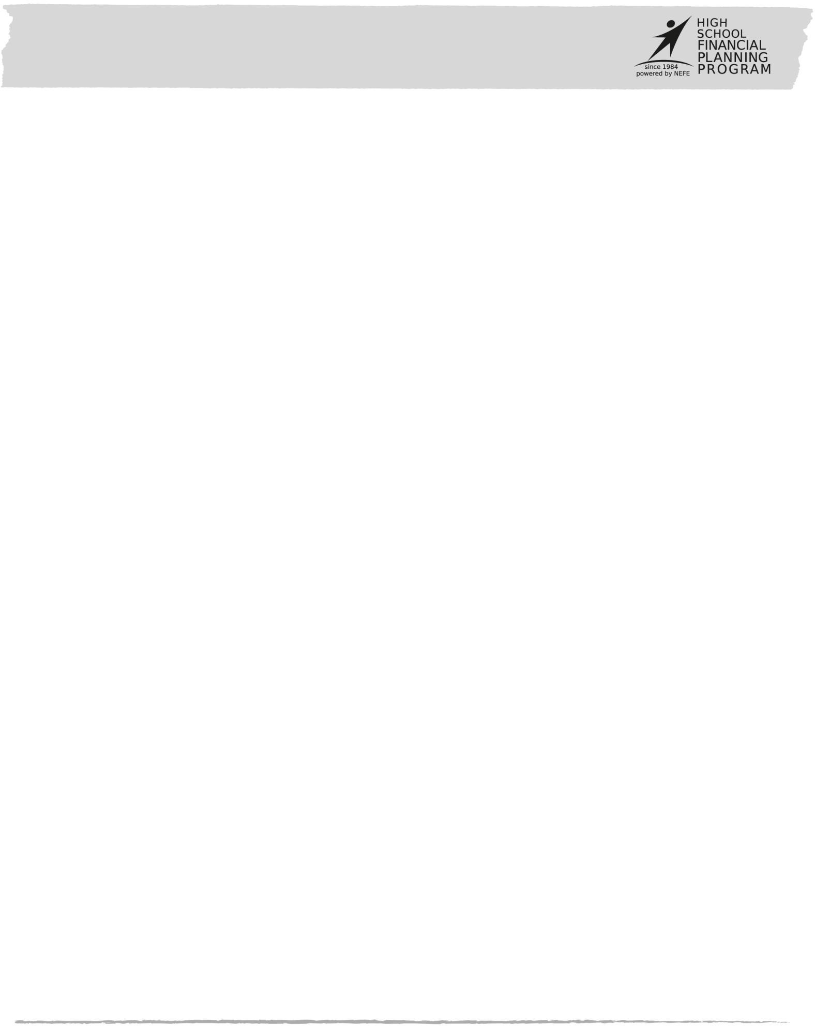**Activity 1.10: My Spending Leaks**

**NAME:**       **DATE:**

Directions:

Looking at your spending log, do you recognize any money leaks? If so, answer these questions about your spending:

|  |  |
| --- | --- |
| *What do I wish I’d done with that money instead?* | *Will it take me longer to reach my financial goals now?* |
| *How can I reduce the impact on my situation now? (Return or sell the item, cancel the membership, etc.)* | *What will I do to keep from making the same mistake again?* |

Check out Spendster, a YouTubeTM-like website that showcases people’s stories of impulse buying, overspending, or just plain wasting money on stuff they don’t need.

Watch their video confessions or submit your own spending story at [www.spendster.org.](http://www.spendster.org/)

# Money Management Self Assessment

## NAME:       DATE:

Directions:

Use the following scale to assess your money management skills. Perform this self-assessment at least once a year.

*5=Always 4=Usually 3=Sometimes 2=Occasionally 1=Never*

|  |  |  |
| --- | --- | --- |
|  |  | I conduct a personal values and spending analysis once a year. |
|  |  | I created a realistic spending plan based on personal values and spending analysis and adjust it yearly, if needed. |
|  |  | I put at least 10 percent of what I earn into a savings account. (PYF) |
|  |  | I have a savings account in my name and make regular deposits. |
|  |  | I adjust my spending plan to match my short-term, medium-term and long-term savings goals. |
|  |  | My spending plan includes a line item for emergencies and opportunities. |
|  |  | I balance my spending plan so expenses do not exceed income |
|  |  | I keep records of all of my purchases. |
|  |  | I track my spending to make sure I stay within my spending plan. |
|  |  | I compare my spending plan to my actual earned income and expenses every month. |
|  |  | I compare my receipts to my bank statement (“reconcile my account”) to make sure there are no mistakes. |
|  |  | I evaluate my purchases based on my needs and not my wants. |
|  |  | My purchases are in line with my money values. |
|  |  | I always comparison shop. |
|  |  | I create a list when I go shopping and I stick to my list. |
|  |  | I avoid impulse buying. |
|  |  | I wait one day before committing to a purchase over $50. |
|  |  | I pay my bills and return borrowed items on time to avoid unnecessary fees and penalties. |
|  |  | I make sure I have enough money in my account before I withdraw money, use my debit card, or write a check to avoid unnecessary fees. |
|  |  | (If I have a job) When I file income taxes, I only owe a small amount or receive a small refund. |
|  | | **TOTAL SCORE**       **ASSESSMENT DATE** |