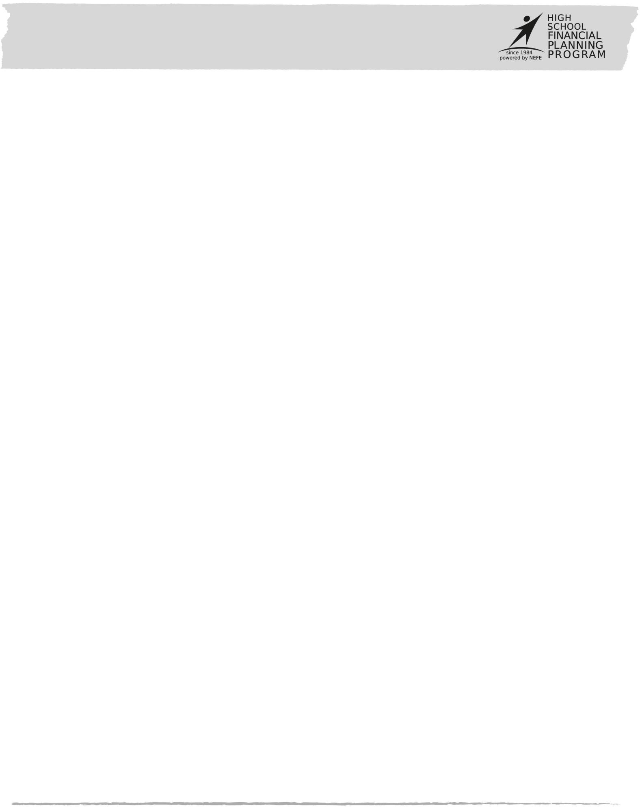STUDENT LEARNING PLAN

# Lesson 2-1: Using Credit

### OVERVIEW

**LEARNING OUTCOMES**

In this lesson you will weigh the benefits and risks of borrowing. Along the way you will:

* Discuss why people borrow.
* Give examples of acceptable and unacceptable situations to use credit.
* Explain how borrowing impacts spending power.

Use what you learn to recognize situations when it makes sense to either use credit or avoid using credit.

Credit cards, auto loans, home mortgages, pawn shops … you’ve probably heard a lot about debt over the years—good and bad. But debt itself is actually neither. It’s merely a tool to buy something now and pay for it later.

How we use debt is what’s good or bad.

This lesson will help you assess reasons to use or not use credit.

|  |  |
| --- | --- |
| **LEARNING TASKS**  These tasks match pages 3-8 and 18-19 in Student Guide 2. | |
| 1. | What do you think are good reasons to borrow money? Participate in a discussion to evaluate situations that involve borrowing money. |
| 2. | Evaluate your borrowing habits by completing Activity 2.1: Borrowing Fitness Test. |
| 3. | Give examples of ways people use credit. Complete Activity 2.2: What is the Reason? |
| 4, | Share a story about a time you made an impulse purchase that you regretted later. Have you ever been glad that you waited to make a purchase? |
| 5. | Mariah’s mom doesn’t think that Mariah should have a credit card. Role play a conversation between Mariah and her mother about the reasons to get or not get a card. |

### REFLECTION

Reflect on your answers for Activity 2.1: Borrowing Fitness Test.

* Which one area would you say is your weakest?
* Write down two things you can do to strengthen your ability for that one area of weakness.

### FURTHER STUDY

Find a news story that relates to the risks or rewards of borrowing. Summarize two or three new things that you learned from the story.

# Activity 2.1: Borrowing Fitness Test

## NAME:       DATE:

Directions:

Do you have what it takes to be a responsible borrower? Find out by answering the questions below.

If you answer “yes” to a question, mark an “X” in the box to the left.

**Do you . . .**

|  |  |
| --- | --- |
| 1. | Repay money loans from friends and family before they have to ask you for it? |
| 2. | Often borrow money to pay for something you can’t afford right now? |
| 3. | Return library books and other borrowed items before they’re due and return them in good condition? |
| 4. | Frequently ask for an advance on your paycheck or allowance? |
| 5. | Replace money you borrow from your savings account or from other spending-plan funds? |
| 6. | Borrow items from your parents or siblings without asking for or getting permission first? |
| 7. | Know how much money you owe others right at this very moment? |
| 8. | Ever make monthly or weekly payments late? |

The more “yes” answers you have on the odd-numbered questions and “no” answers on the even-numbered questions, the more fit you are to be a smart borrower!

If you didn’t do well, don’t worry. It’s never too late for a bad-habit makeover.

# Activity 2.2: What is the Reason?

## NAME:       DATE:

### MEET MARIAH AND JESSE

Mariah is upset. Her mom said “no way!” to helping her get a credit card. Mariah pointed out that she has a part-time job at the mall to pay the bills and that she’s a junior now and will be going off to college soon—but her mom wouldn’t even discuss it.

Jesse dreads the thought of having to drive the family clunker next year when he gets his license. He doesn’t have a job, but he’s been saving for a few years and has $2,500 now, which he was hoping to use to spend on a truck—until he actually started checking out truck prices. Jesse’s older brother said their parents might agree to co-sign a loan for him if he gets a job before then.

1. What do you think is Mariah’s reason for getting a credit card?

1. What do you think is Jesse’s reason for using a loan to buy a truck?

1. Finally, what has prompted you to borrow money from friends or family?

|  |  |  |  |
| --- | --- | --- | --- |
| **Reason to Borrow**  Read about each reason on page 7 in Student Guide 2. | **Mariah** | **Jesse** | **Me** |
| Convenience |  |  |  |
| Instant gratification |  |  |  |
| Protection |  |  |  |
| Emergencies |  |  |  |
| Spreading out payments for expensive items |  |  |  |
| Investments |  |  |  |
| Credit history |  |  |  |
| Special offers and perks |  |  |  |

# Task: News Summary

## NAME:       DATE:

Directions:

Locate a news story that relates to the risks or rewards of borrowing. Be prepared to share what you find either as a written or a verbal summary.

Include the following information in your summary.

* News Story Title
* Story Source (name the magazine, newspaper, website the story came from)
* Specific Location (page number(s), website address)
* Date (The story should have been written or posted during the past week)
* Summary of the News Story (Answer the following questions with a complete sentence for each.)
  1. Who? (Who should the story concern? Who are the major players?)
  2. What? (What is going on? What happened?)
  3. Where? (Where did/does this happen?)
  4. When? (When did it happen? What is the timeline?)
  5. How? (How did it happen?)
  6. Why? (Why did it happen? Why are the involved people behaving a certain way?)
  7. So what? (Why should you care? How can this impact you?)

Resources:

You can find local, state and national news from the school library, the town/city library, and news websites. If they see or hear a news story on television or the radio, chances are pretty good that the radio or television station has a website that will also contain that story. If possible, bring a copy of the story to share with your summary.

# Task: News Summary

Written Summary: