STUDENT LEARNING PLAN

# Lesson 3-3: Pay and Taxes

### OVERVIEW

**LEARNING OUTCOMES**

In this lesson you will examine factors that impact personal tax liability and take-home pay. Along the way you will:

* Calculate net pay.
* List factors that impact personal income tax liability.
* List factors that impact your net pay.

Use what you learn to maximize your pay options.

If your job pays $8 an hour and you work 20 hours, your paycheck will be $160, right? The reality is, what you earn is not the same as what you actually receive to spend as you wish. After taxes and other items are deducted from your paycheck, you will have less money in hand to save, spend, or invest.

In this lesson you will investigate factors that impact your take-home pay and learn about choices you have to make the most of your hard-earned money.

|  |  |
| --- | --- |
| **LEARNING TASKS**  These tasks match pages 21-25 in Student Guide 3. | |
| 1. | If Kevin earns $6.50 an hour and worked 60 hours last month, how much did he earn for the entire month? Complete Activity 3.8: Check it Out! to see how much money he actually took home. |
| 2. | What do you know about taxes? Participate in a discussion on how taxes are paid. Then brainstorm reasons why we need to pay taxes. |
| 3. | Find out the financial decisions you need to address when starting a new job. Make one of your first adult financial decisions when you fill out an IRS Form W-4. |
| 4. | Congratulations! You are now earning $30,000 a year. Calculate your net, or take-home, pay. |
| 5. | Complete Challenge 3-B: Thumbs Up or Thumbs Down? to identify potential job options and payroll options that match your preferences. |

#### TAKING IT HOME

Take a close look at one of your recent paystubs to

see how payroll information is recorded. Keep your paystubs to match up data on the W-2 Wage and Tax Statement you receive from your employer at the end of the year. This information is needed when filing your income taxes.

#### FURTHER STUDY

Know the special rules related to teen employment.

Check out Youth Rules ([www.youthrules.dol.gov](http://www.youthrules.dol.gov/)), a website hosted by the U.S. Department of Labor. The site provides current information about federal and state youth labor laws, including the hours youth can work, the jobs youth can do, and how to deal with any employment violations. Share this information with your peers.

#### REFLECTION

Think about the number of W-4 allowances you

think best reflects your needs right now. Now, imagine into the future and indicate how you will change your number of allowances for each of the following scenarios and why.

* You accept your first full-time job.
* You just got married, and your spouse also works full-time.
* Your first child is just born.

#### FURTHER STUDY

Practice filling out an income tax form. You can

find simulations for several situations on the IRS.gov Understanding Taxes Student Site, [www.irs.gov/app/understandingtaxes](http://www.irs.gov/app/understandingtaxes)



©2014 National Endowment for Financial Education [www.hsfpp.org](http://www.hsfpp.org/) Lesson 3-3: Pay and Taxes High School Financial Planning Program June 2014

# Activity 3-7: Get the W-4 Right

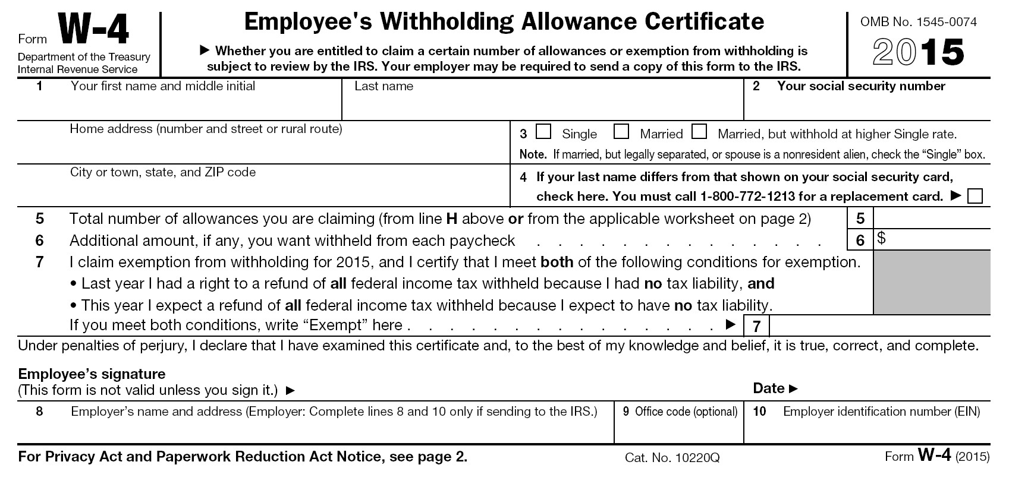

## NAME:       DATE:

#### Directions:

When you begin a new job, you will complete Form W-4 so that your employer can withhold the correct federal income tax from your pay. Use the form below to practice filling out a form based on your current situation.

You can download a copy of the full IRS Form W-4 from www.irs.gov for additional instructions to fill out the withholding allowance information.

Complete editable W4 online: <https://www.irs.gov/pub/irs-pdf/fw4.pdf>

Keep your Social Security number a secret; use 000-00-0000 to fill out this form.

# Activity 3-8: Check it Out!

## NAME:       DATE:

#### Directions:

Use the information provided to calculate Kevin’s net pay.

Kevin earns $6.50 an hour and worked 60 hours last month. During the month he received

$148 in tips. He also used his employee food discount and chose to have the cost of his meals deducted from his paycheck.

If Kevin had $21 deducted last month for meals, what was his net pay?

|  |  |  |
| --- | --- | --- |
| **Calculating Your Income** | | **Kevin’s Monthly Pay** |
|  | Regular Pay | $ |
| + | Tips | $ |
| = | Gross Pay | $ |
| - | Payroll Taxes | $ 77 |
| - | Other Deductions | $ |
| = | Net Pay | $ |

# Task: Figure the Net Pay



## NAME:       DATE:

#### Directions:

Situation A. Congratulations! You are now getting a regular paycheck. Although your annual salary is

$30,000, you know that there are several deductions that will be taken out of your paycheck. Use the data provided in the chart to calculate your net pay (aka take-home pay) for each pay period.

Situation B. You just found out that your employer will match a portion of any contributions you make to a retirement fund. To take advantage of this generous benefit, you have chosen the option to automatically have $100 deducted from each paycheck to build up your retirement fund. You can take this as a pre-tax deduction, meaning your income taxes will be calculated *after* subtracting your retirement fund deduction of $100 per pay period. Calculate how this pre-tax deduction impacts your total taxes and your net pay.

Situation C. At your one-year review you received good news—you have earned a three percent raise for taking on new responsibilities and being a valued employee! Recalculate your net pay to see how your raise impacts your tax liability and net pay.

What is the difference between your original gross pay (A1) and your gross pay after your raise (C1)?

Gross Pay: $      after raise per pay period $      after raise over one year

If you continue to contribute $100 to your retirement fund each pay period, what is the difference in what you owe in **taxes** and your net pay comparing Situation A and Situation C?

Total Taxes: $      after raise per pay period $      after raise over one year

Net Pay: $      after raise per pay period $      after raise over one year

# Task: Figure the Net Pay

|  |  |  |  |  |  |  |
| --- | --- | --- | --- | --- | --- | --- |
|  | **Filing Status:**   * Single * 1 Withholding Allowance * Paid semimonthly | **Situation A** | **Situation B** | **Situation C** | **Difference C-A** | **Difference Over One Year (C-A)** |
| 1 | Gross Pay | $1,250 | $1,250 | $1,287.50 |  |  |
| 2 | Retirement Fund Contribution Pre-Tax Deduction | $0 | $100 | $100 |  |  |
| 3 | Taxable Pay |  |  |  |  |  |
| 4 | Federal Income Tax* | $129.00 | $114.00 | $120.00 |  |  |
| 5 | State Income Tax  (4.63% of taxable income, CO rate) |  |  |  |  |  |
| 6 | Social Security FICA Tax  (6.2% of gross income) |  |  |  |  |  |
| 7 | Medicare FICA Tax  (1.45% of gross income) |  |  |  |  |  |
| 8 | Total Tax Deduction |  |  |  |  |  |
| 9 | Union Dues | $15.71 | $15.71 | $15.71 |  |  |
| 10 | Total Deductions |  |  |  |  |  |
| 11 | Net Pay |  |  |  |  |  |

*The federal income tax has been calculated for you based on filing status and 2015 Tax Tables, IRS pub. 15.