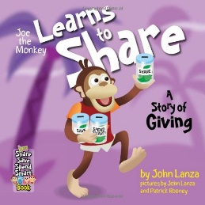:

**Joe the Monkey Learns to Share**

**Author: John Lanza**

**Suggested Ages 8-12**

**Time: 45 min**

**Lesson:**

* Save/Spend/Share Concept
* Finding Your Passion
* Donating/Volunteering
* Benefits of Having an Account

Read the book aloud to the students. Pause at various points in the book to talk about how it feels to give to others. Ask for examples of how the students help others.

Questions to encourage discussion:

Joe spent money from his “Save” jar on his Supervine and his microphone. Money from his “Spend” jar went to his tube of tail grip. What is the difference in things he bought with his “Save” money and things he bought with his “Spend” money? Talk about short term vs long term goals.

How did Joe’s friends use their “Share” money? Do you have money you set aside to share with others or to donate?

What is the difference in donating to a charity or letting someone borrow money?

If you don’t have money to share, what are other ways to help someone?

Why was it important that Joe find his own charity? Use this opportunity to talk about passion and finding your “WHY”.

Instead of jars, how many of you have a savings account? What are the benefits? Discuss the benefits of keeping your money in an account when you don’t need access to it right away (your “Save” and “Share” money). Benefits may include: 1) interest 2) safety 3) less temptation to spend.

**Suggested Activity:**

1. Talk to the teacher before-hand about organizing a class fund-raiser. Agree on a list of options and have the students vote on the one they would like to raise money for. Gather ideas on how to raise the money.
2. Draw a “Save” “Spend” and “Share” jar each on a large poster. Write the name of various items on slips of paper and ask for a volunteer to tape each item on the jar they think it belongs on. For example, short-term goals will likely go in the “Spend” jar while longer term goals will go in the “Save” jar and donations will go in the “Share” jar.

Materials Needed:

3 poster boards

Markers

Slips of paper (any size)

Tape