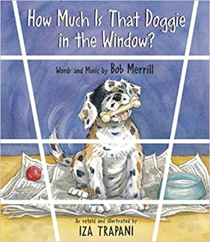:

**Suggested Ages 5-10**

**Time: 45 min**

**Lesson:**

* Goal Setting
* The Importance of Saving
* Earning Money
* Hidden Costs
* Knowing Your Options

Read the book aloud to the students. Pause at various points in the book to talk about the process of setting a goal, saving for that goal and other things to consider when goal setting for a big purchase.

**Questions to encourage discussion:**

Ask the students how many of them have a pet. Keep the discussion controlled as many will want to talk about their pet or show pictures. If you want to ask what type of pets, do it by raising of the hands (how many have dogs, how many have cats, how many have outside animals…like horses).

What costs come with owning a pet? Use this opportunity to talk about hidden costs (you may get a pet for “free” but then what are some things you may have to buy…food, vet care, grooming, dog bed, boarding, etc)

What did the boy do to raise money for the dog? Ask the students what they can do to raise extra money.

The dog in the story was in a shop. Where else might you be able to find a pet for less money? Talk about the potential pros and cons of adopting a pet or buying one from someone’s home.

**Suggested Activity:**

1. Ask the students to stand in the middle of the classroom. Have the teacher put a sign in one corner of the room that says “1”, one in another corner that says “2” and one in yet another corner that says “3”. Ask the students a series of questions and have them go to the corner that corresponds to their answer after each question. Here are some examples of questions:
   1. If you own a dog, go to 1, cat owners go to 2, if you have both go to 3, if you don’t have any, stay in the center.
   2. What is the average vet bill for a puppy for the first year? (assign various ranges to the numbers).
   3. What do you think the cost of a “Labradoodle” is? (assign various ranges to the numbers).
   4. What is the most popular type of pet (dog, cat, fish)?

Materials needed:   
Drawing paper

Markers

**How Much is That Doggie in the Window?**

**Author: Bob Merrill**