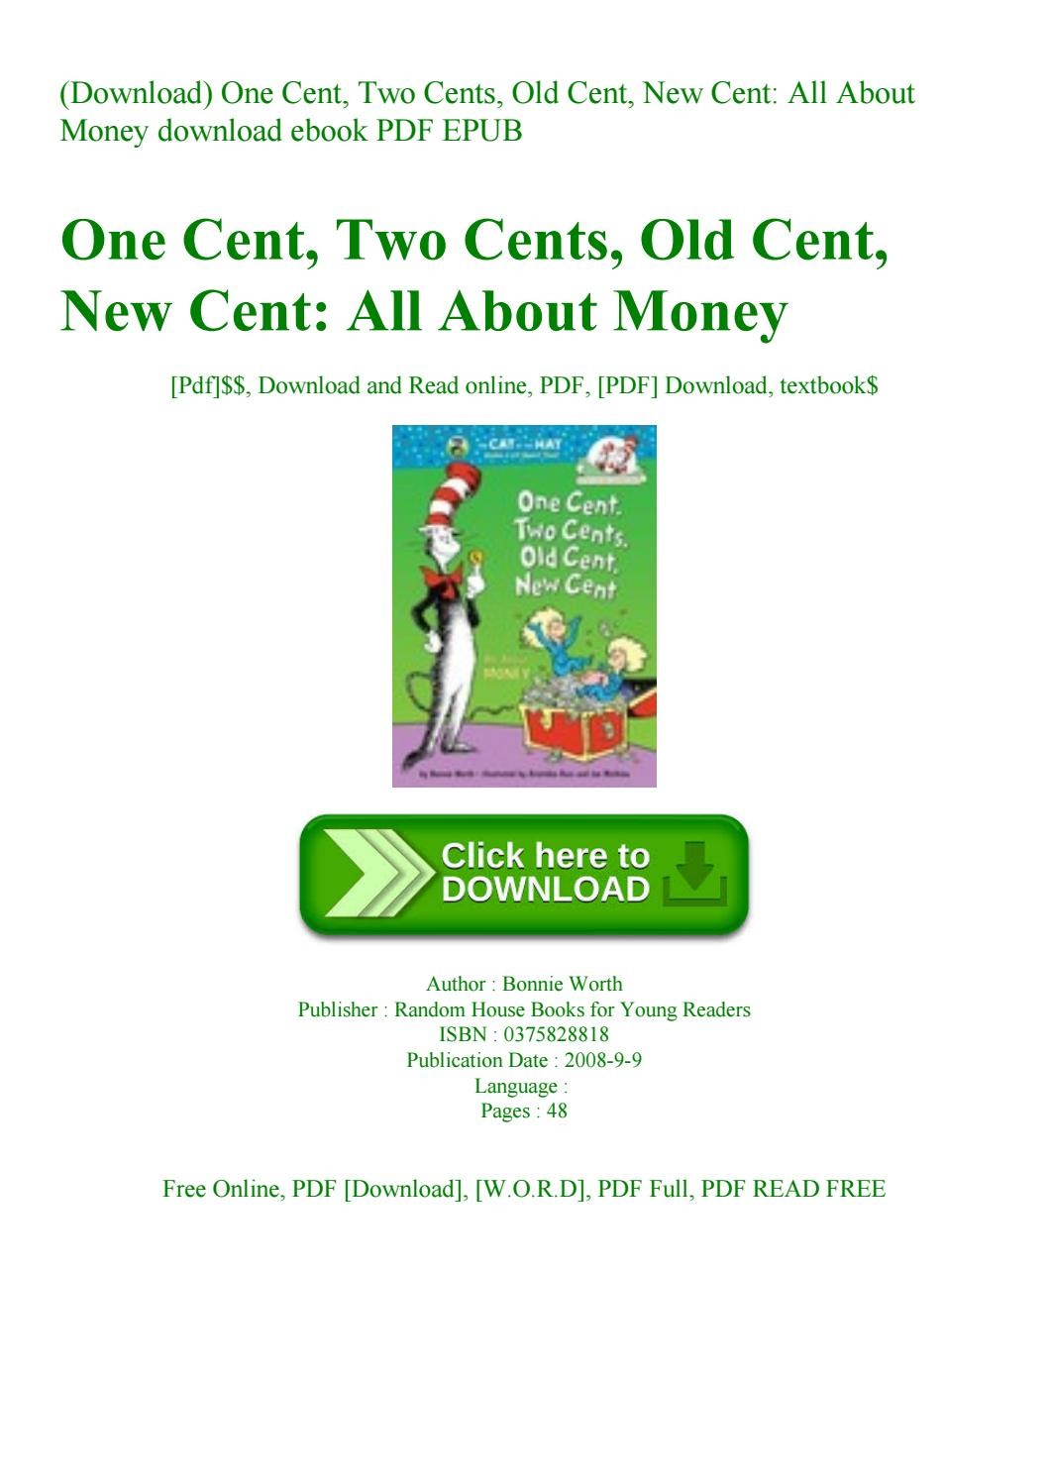:

**Suggested Ages 7-11**

**Time: 45 min**

**Lesson:**

* History of Money/Money Around the World
* Bartering
* How Interest Works
* How Money is Made

Although this is an “elementary” book, the lesson can be easily expanded to benefit up to high school age.

Read the book aloud to the students. Pause at various points in the book to talk about the history of money and the types of money around the World. It would also be good to add in the values of different types of money.

**Questions to encourage discussion:**

What is bartering? You can see it has been around even before money was invented. What are some ways that you have bartered in the past (have you traded something for something else)?

Have you seen any old money or money from other countries? Ask your parents if they have any!

What is the difference between interest on money you borrow and interest on money you save?

What are the advantages to saving money in a bank or credit union?

What faces appear on our current money (bills and coins)? Are they all Presidents?

Where is money made in the U.S.?

**Suggested Activity:**

1. Take samples of old coins and money from other countries for the students to examine.
2. Take paper, cut the size and shape of a dollar, and have the students come up with their own design for a new bill. Have them be creative with the amount, the face and the writing on the bill. Then have them explain their choices in front of the class.

Materials needed:

Pre-cut paper or poster board (one for each student), markers, pencils, stamps, etc.

1. Have each student or group of students choose a country and look up their currency. Then have each student or group draw a picture or make a replica of a coin or bill that they find (can be old or new). They can then do a quick presentation in front of the class on why that country chose to design that coin or bill in that way (historic facts).

Materials needed:

Variety of materials to make or draw bills or coins (paper, clay, markers, stamps, tracing paper, etc)

**One Cent, Two Cents, Old Cent, New Cent**

**Author: Bonnie Worth**