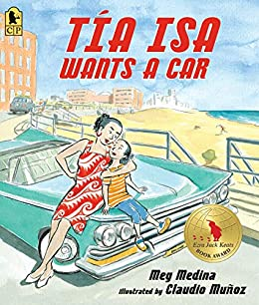:

**Suggested Ages 8-13**

**Time: 45 min**

**Lesson:**

* Needs vs Wants
* The Importance of Saving
* Goal Setting
* Hidden Costs

Read the book aloud to the students. Pause at various points in the book to talk about the process of setting a goal, saving for that goal and other things to consider when goal setting for a big purchase. As you go through the story, make a list of the Spanish words and ask the students later if they know what they mean.

**Questions to encourage discussion:**

Why do you think that Tia wants a car?

Tia is talking about the color of the car and where she wants to go. What else should Tia consider before buying a car?

Tio didn’t believe that Tia would reach her goal of getting a car. Ask the students if they have ever come across someone discouraging them from setting or reaching a goal. How did they handle it?

Tia Isa’s niece tries to help her raise money for the car by doing odd jobs. What are some things you can do to make extra money?

Why do you think that Tia Isa looks at an older car? Use this opportunity to talk to older students about the pros and cons of buying a used car vs a new car. What are other expenses that come with car ownership?

The car she chooses does not have air condition or a good radio. Are those “needs”? Ask the students what their list of “needs” would be when looking for a car. What about “wants”?

Where did Tia Isa keep her money? What are the advantages to having your money in an account rather than keeping it in an envelope? (it earns interest, less temptation to spend on “wants”, safety) Ask the students how many of them have a savings account.

**Suggested Activity:**

1. Have the students make a vision board of the car that they would like to have one day. What will it look like? Make 2 columns for the “wants” and the “needs” of the car. Have them research the cost of the car (new vs used) and the cost of insurance (for older students). You can also pre-print popular types of vehicles and have them on posters or separate sheets.

Materials needed:   
Drawing paper

Markers

Pre-printed car comparison sheets

**Tia Isa Wants a Car**

**Author: Meg Medina**