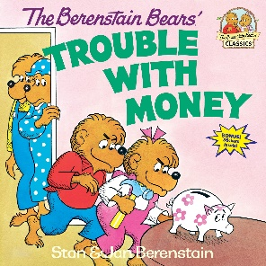:

**Suggested Ages 4-8**

**Time: 45 min**

**Lesson:**

* Needs vs Wants
* The Importance of Saving
* Ways to Earn Money/Entrepreneurship
* Bank vs Credit Union

Read the book aloud to the students. Pause at various points in the book to talk about the choices that the cubs make regarding spending, earning and saving.

**Questions to encourage discussion:**

The bears knew a lot about many things but not about money. Who could YOU ask when you have questions about money?

What are some ways that you can earn money? What were some things the bears did to be successful at their new businesses (what made their business different from others)?

What is your favorite restaurant? What makes it your favorite?

Papa Bear says that some things are more important than money. What do you think is more important?

What are the advantages of saving money rather than spending it?

What does it mean to have a “nest egg”? (Talk a little about retirement)

The bears took their money to a bank. When you are saving money, where is a safe place to keep it? (Talk about savings accounts and the basic differences between a bank and a credit union)

What are the advantages to having your money in an account rather than keeping it under your mattress or in your sock drawer? (it earns interest, less temptation to spend on “wants”, safety)

**Suggested Activity:**

1. Create a two-column table or use two different sheets of paper or poster board. You can have each student make their own or you can have large poster boards for the entire class to use together. Doing the activity together promotes more discussion. Label one “Needs” and the other “Wants”. After the book, ask the students to name an item and have the class vote on whether it is a need or a want.

Materials needed:   
2 large poster boards, marker (or your can use a white board or chalk board)

1. It’s time to come up with YOUR own business idea! Have the students work in groups to come up with their own business idea. For older kids, leave it open. They can come up with a service or a product of any type…but they have to show how their new idea is better than any competitor that may be out there. For younger kids, narrow the focus by having them come up with a new restaurant idea. Talk about who they want to target, what they will serve and what their name and tag line will be. Have each group create an advertisement for their new business idea and the group will have 3 minutes to present it to the class.

Materials needed:

Poster boards for an advertisement, markers

**The Berenstain Bears’ Trouble With Money**

**Author: Stan & Jan Berenstain**